**E-TICKET SYSTEM:**

USE CASE DIAGRAM:

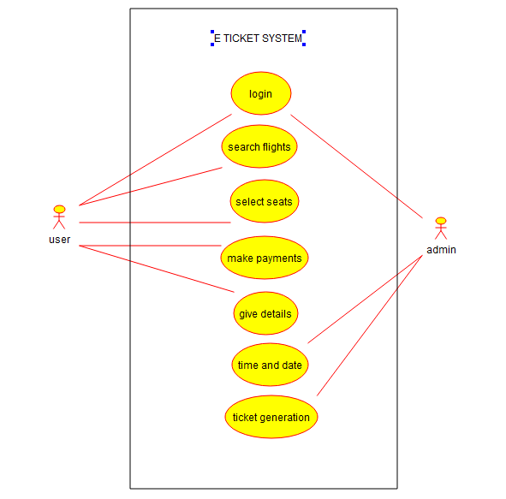

STATE DIAGRAM:

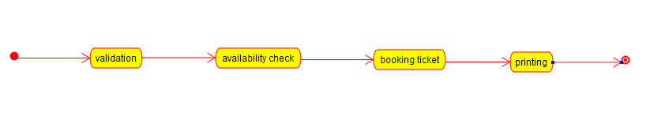

ACTIVITY DIAGRAM:

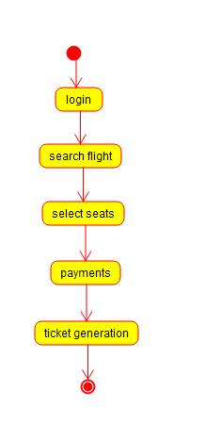

CLASS DIAGRAM:

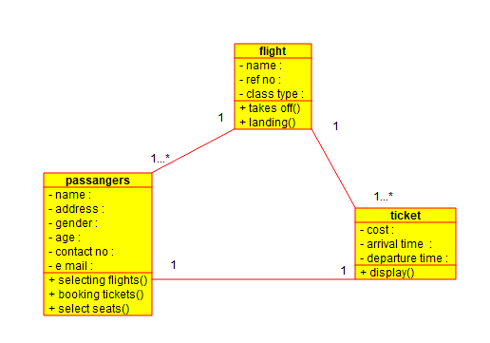

DEPLOYMENT DIAGRAM:

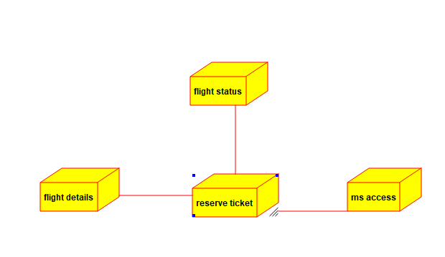

COMPONENT DIAGRAM:

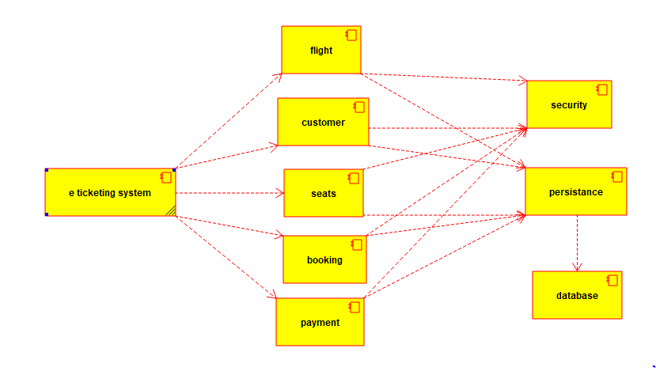

SEQUENCE DIAGRAM:

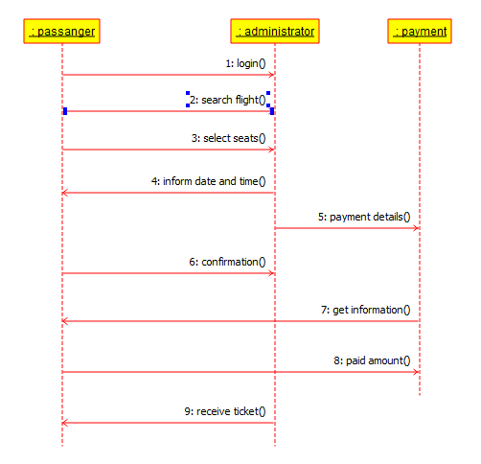

**CREDIT CARD PROCESSING SYSTEM:**

DEPLOYMENT DIAGRAM:

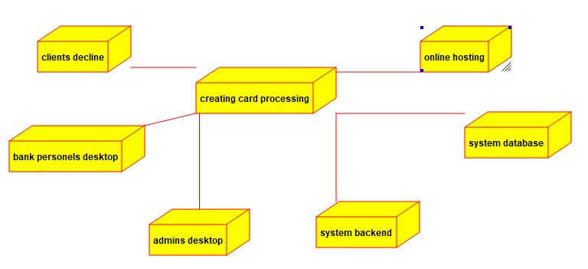

USE CASE DIAGRAM:

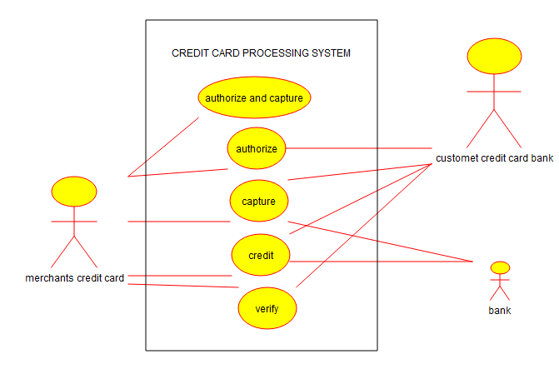

CLASS DIAGRAM:

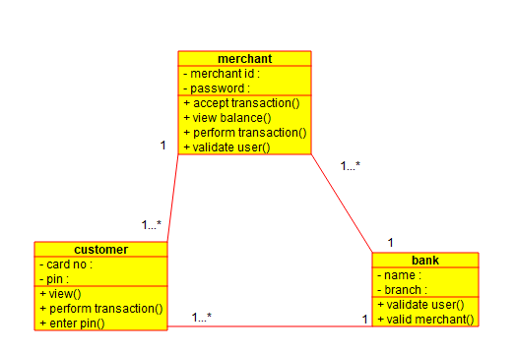

ACTIVITY DIAGRAM:

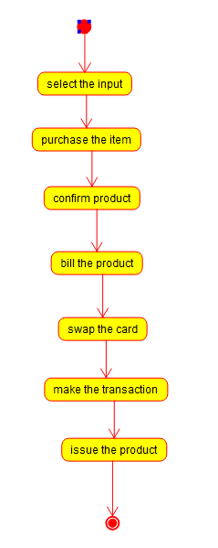

STATE DIAGRAM:

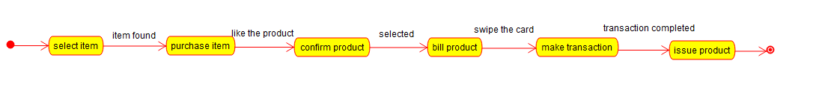

COMPONENT DIAGRAM:

